**Top 50 Linux System Administrator Interview Questions**

July 19, 2016

**SHARE**

**[Facebook](http://www.facebook.com/sharer.php?u=https%3A%2F%2Ffossbytes.com%2Ftop-50-linux-system-administrator-interview-questions-answers%2F)**

**[Twitter](https://twitter.com/intent/tweet?text=Top+50+Linux+System+Administrator+Interview+Questions&url=https%3A%2F%2Ffossbytes.com%2Ftop-50-linux-system-administrator-interview-questions-answers%2F&via=%40fossbytes14)**

***[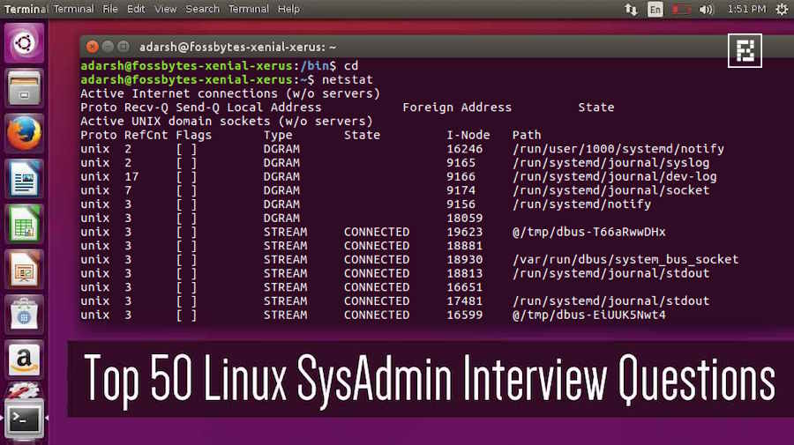](http://fossbytes.com/wp-content/uploads/2016/07/linux-sysadmin-interview-question.jpg)Short Bytes:****Today, the job opportunities for Linux experts are more than ever. The Linux SysAdmin interview questions range from basic Linux questions to networking, DevOps, and MySQL questions. So, one needs to prepare adequately to ensure success in the Linux system administrator interview process.*

According to a report, the [open source and Linux job market](http://fossbytes.com/learn-linux-open-source-jobs-hot-right-now/) is full of new opportunities. Due to the increasing adoption of open source technologies by the technology giants ([Microsoft says HELLO!](http://fossbytes.com/tag/microsoft-loves-linux)), there are ample job opportunities for system administrators and DevOps professionals.

While a huge demand continues to exist, just like any other job in the technology world, SysAdmins have to go through a rigorous hiring process that consists of preparing a professional resume, technical exams, and interview questions. Out of these, cracking a job interview is often the most critical test.

During an interview, a candidate’s personal qualities are also checked and it’s evaluated if he/she is a right fit for the company. Apart from being calm and composed, being well-prepared for an interview is the best thing one can do in order to crack a Linux SysAdmin interview.

If you open your web browser and search for the phrase *Linux SysAdmin interview questions*, you’ll get a long list of search results that will help your practice. Apart from the straightforward conceptual questions like “What does the permission 0750 on a file mean?”, Linux SysAdmin interviews also come loaded with expert questions like “How do you catch a Linux signal on a script?”

To help you out in the Linux system administrator  interviews, I’ve compiled a list of my favorite questions of variable difficulty. These questions are framed with different approaches to find out more about the candidate and test his/her problem-solving skills:

1. What does nslookup do?

2. How do you display the top most process utilizing CPU process?

3. How to check all open ports on a Linux machine and block the unused ports?

4. What is Linux? How is it different from UNIX?

5. Explain the boot process of Unix System in details.

6. How do you change the permissions? How to create a file that’s read-only property?

7. Explain SUDO in detail. What are its disadvantages?

8. What is the difference between UDP and TCP?

9. Describe the boot order of a Linux machine.

10. Design a 3-tier web application.

11. Sketch how you would route network traffic from the internet into a few subnets.

12. How do you know about virtualization? Is it good to use?

13. What are different levels of RAID and what level will you use for a web server and database server?

14. List some latest developments in open source technologies.

15. Have you ever contributed to an open source project?

16. Systems engineer or a systems administrator? Explain?

17. List some of the common unethical practices followed by a system professional.

18. What is the common size for a swap partition under a Linux system?

19. What does a nameless directory represent in a Linux system?

20. How to list all files, including hidden ones, in a directory?

21. How to add a new system user without login permissions?

22. Explain a hardlink. What happens when a hardlink is removed?

23. What happens when a sysadmin executes this command: chmod 444 chmod

24. How do you determine the private and public IP addresses of a Linux system?

25. How do you send a mail attachment using bash?

26. Tell me something about the Linux distros used on servers.

27. Explain the process to re-install Grub in Linux in the shortest manner.

28. What is an A record, an NS record, a PTR record, a CNAME record, an MX record?

29. What is a zombie process? State its causes?

30. When do we prefer a script over a compiled program?

31. How to create a simple master/slave cluster?

32. What happens when you delete the source to a symlink?

33. How to restrict an IP so that it may not use the FTP Server?

34. Explain the directory structure of Linux. What contents go in /usr/local?

35. What is git? Explain its structure and working.

36. How would you send an automated email to 100 people at 12:00 AM?

37. Tell me about ZFS file system.

38. How to change the default run level in a Linux system?

39. How would you change the kernel parameters in Linux?

40. State the differences between SSH and Telnet.

41. How would you virtualize a physical Linux machine?

42. Tell me about some quirky Linux commands.

43. Explain how HTTPS works.

44. Do you know about TOR browser? Explain its working.

45. How to trigger a forced system check the next time you boot your machine?

46. What backup techniques do you prefer?

47. Tell me something about SWAP partition.

48. Explain Ping of Death attack.

49. How do you sniff the contents of an IP packet?

50. Which OSI layer is responsible for making sure that the packet reaches its correct destination?